**Ideation Phase**

**Define the Problem Statements**

| Date | 28 September 2022 |
| --- | --- |
| Team ID | PNT2022TMID22468 |
| Project Name | Project - Plasma Donor Application |
| Maximum Marks | 2 Marks |

**Customer Problem Statement :**

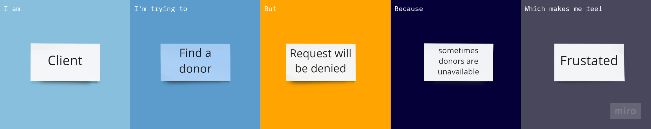

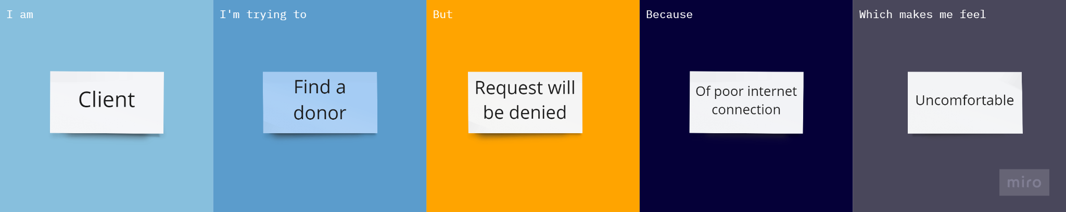

| **Problem Statement (PS)** | **I am (Customer)** | **I’m trying to** | **But** | **Because** | **Which makes me feel** |
| --- | --- | --- | --- | --- | --- |
| PS-1 | Client | Find a donor | Request will be denied | Sometimes donors are unavailable | Frustated |
| PS-2 | Client | Find a donor | Request will be denied | Of poor internet connection | Uncomfortable |